**DAILY ONLINE ACTIVITIES SUMMARY**

|  |  |  |  |  |  |  |  |  |
| --- | --- | --- | --- | --- | --- | --- | --- | --- |
| **Date:** | **08-6-2020** | | | | | **Name:** | **Likhitha.M** | |
| **Sem & Sec** | **6th sem ‘A’** | | | | | **USN:** | **4al17cs046** | |
| **Online Test Summary** | | | | | | | | |
| **Subject** | | **Cryptography, Network Security and Cyber law** | | | | | | |
| **Max. Marks** | | **60** | | **Score** | | | **7** | |
| **Certification Course Summary** | | | | | | | | |
| **Course** | **Introduction to Ethical Hacking** | | | | | | | |
| **Certificate Provider** | | | **Great learning** | | **Duration** | | | **3 days** |
| **Coding Challenges** | | | | | | | | |
| 1.C Program to Generate All the Set Partitions of n Numbers Beginning from 1 and so on  2.Write C++ program to Check whether a number can be represented as difference of two squares  3. Java program to delete a node from the middle of the singly linked list  In this program, we will create a singly linked list and delete a node from the middle of the list. To accomplish this task, we will calculate the size of the list and then divide it by 2 to get the mid-point of the list. Node temp will point to head node. We will iterate through the list till midpoint is reached. Now, the temp will point to middle node and node current will point to node previous to temp. We delete the middle node such that current's next node will point to temp's next node.  4. Program program to find whether a string is a palindrome or not  Description: Write a python function that will take a string and checks whether it is a palindrome or not. Return If it a palindrome, print true else print false  Eg: String is : 'aba' Output: True | | | | | | | | |
| **Status: completed** | | | | | | | | |
| **Uploaded the report in Github** | | | | | **yes** | | | |
| **If yes Repository name** | | | | | **https://github.com/likhithaMantaral/Daily-status** | | | |
| **Uploaded the report in slack** | | | | | **yes** | | | |

Online test Details:

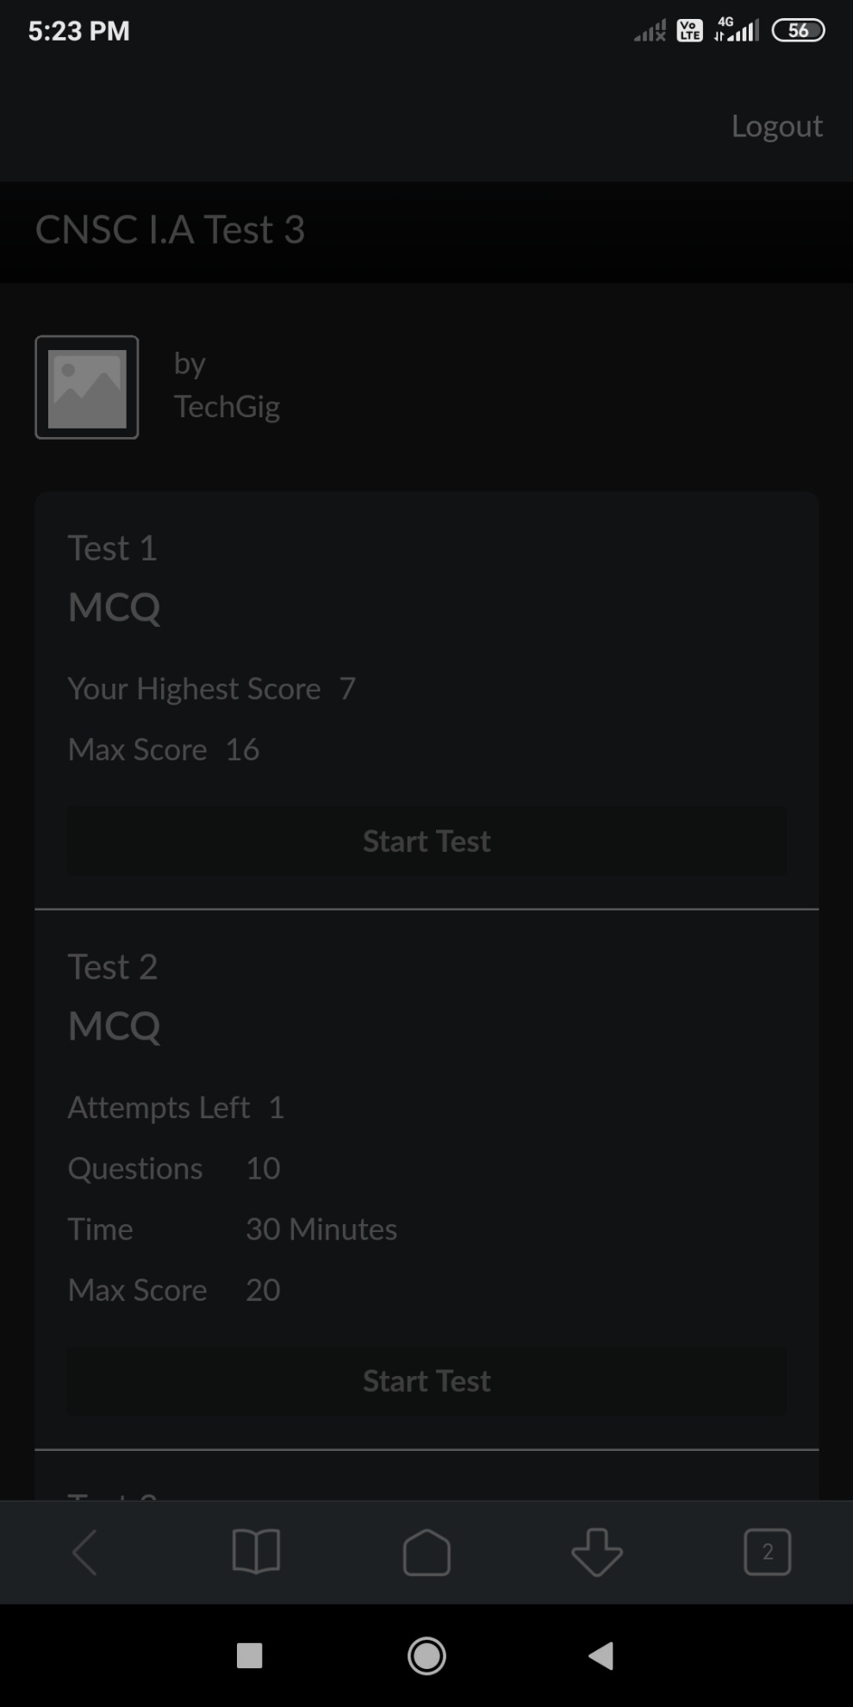

Certification Course Details:

**Domains and Process Implementation under Ethical Hacking**

Domains under Ethical Hacking:

Web application Domain, Mobile, Network architecture Domain, And many more.

Web application domain:-

Two major categories - Client side, server side vulnerabilities.

All the attacks can be categorized into 3 major attacks - Parameter tampering, Unvalidated Inputs, Directory Transversal attacks.

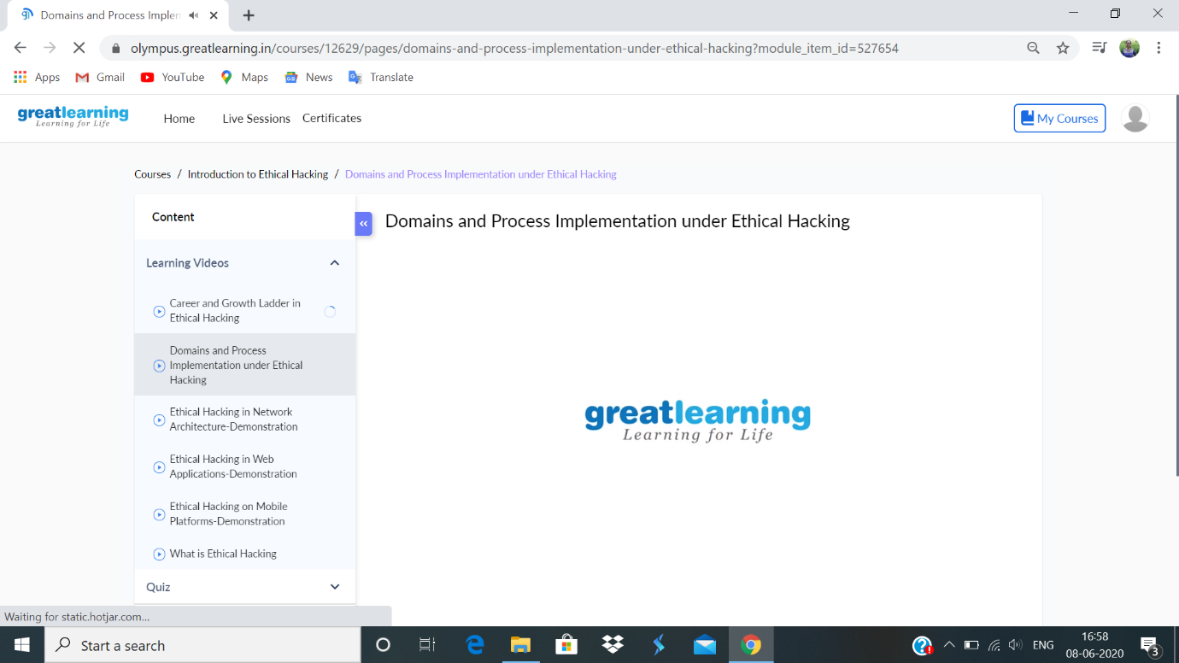

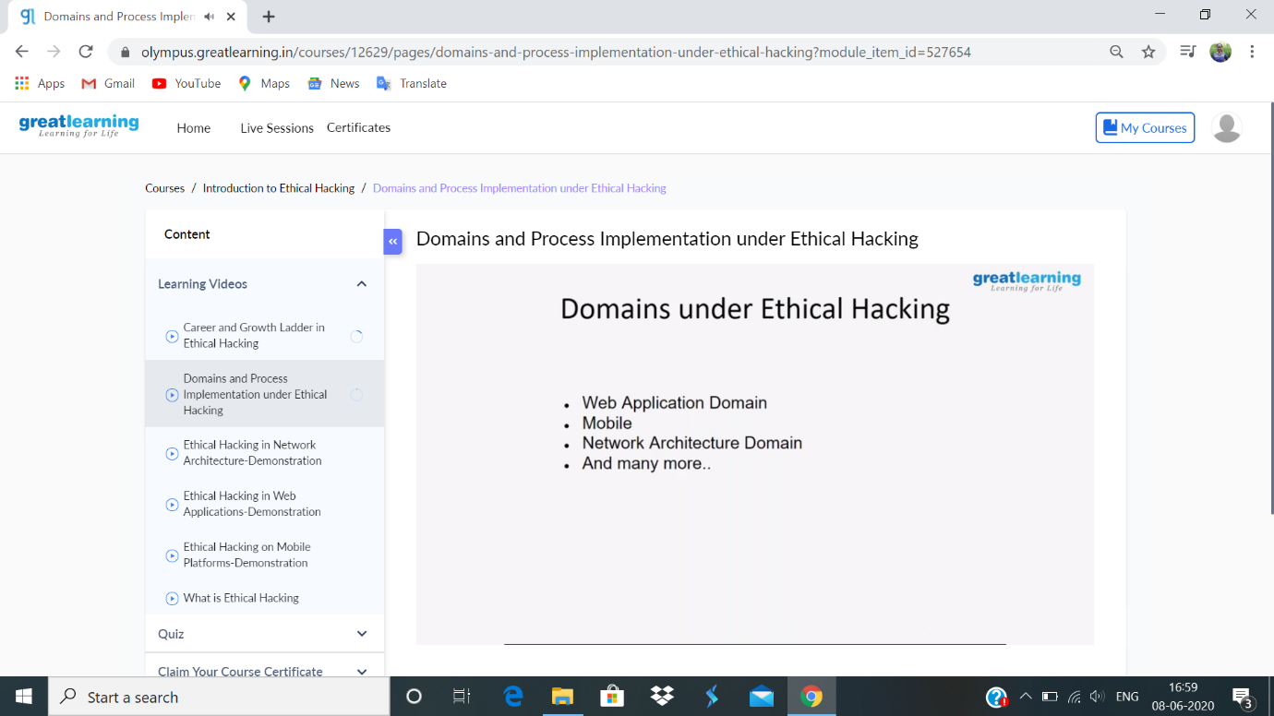

**Coding challenge:**

**1.**

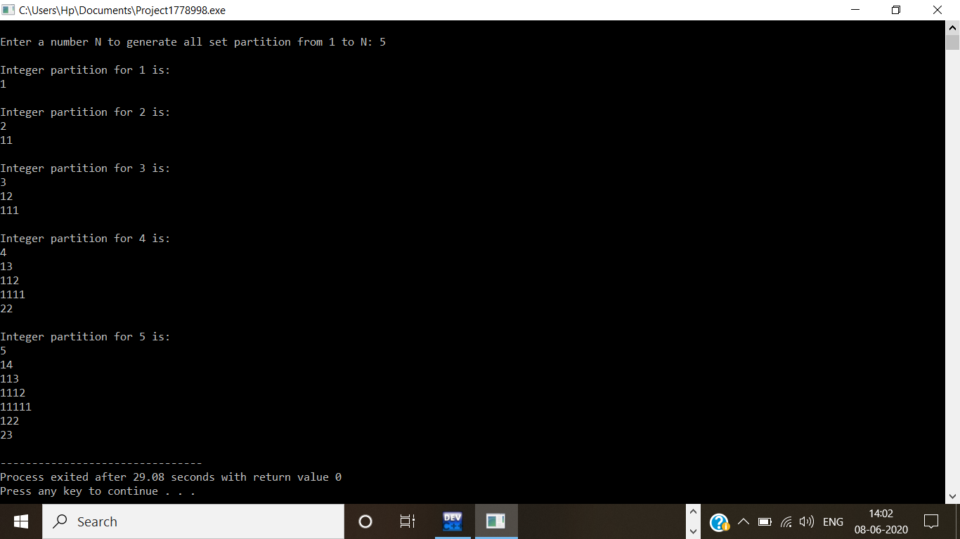

2.

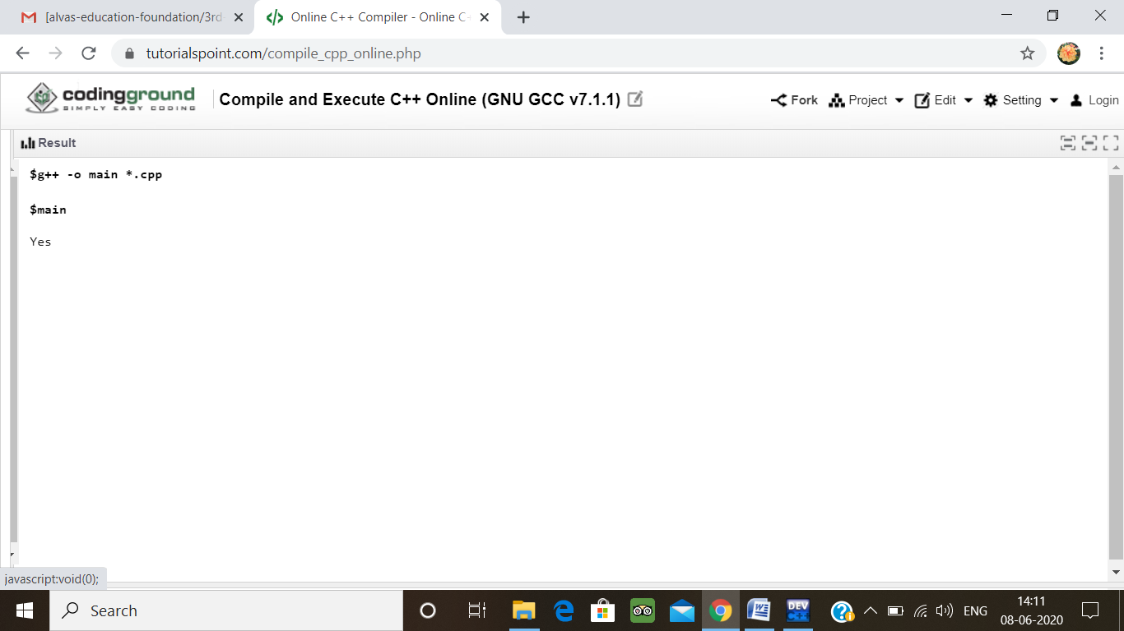

3.

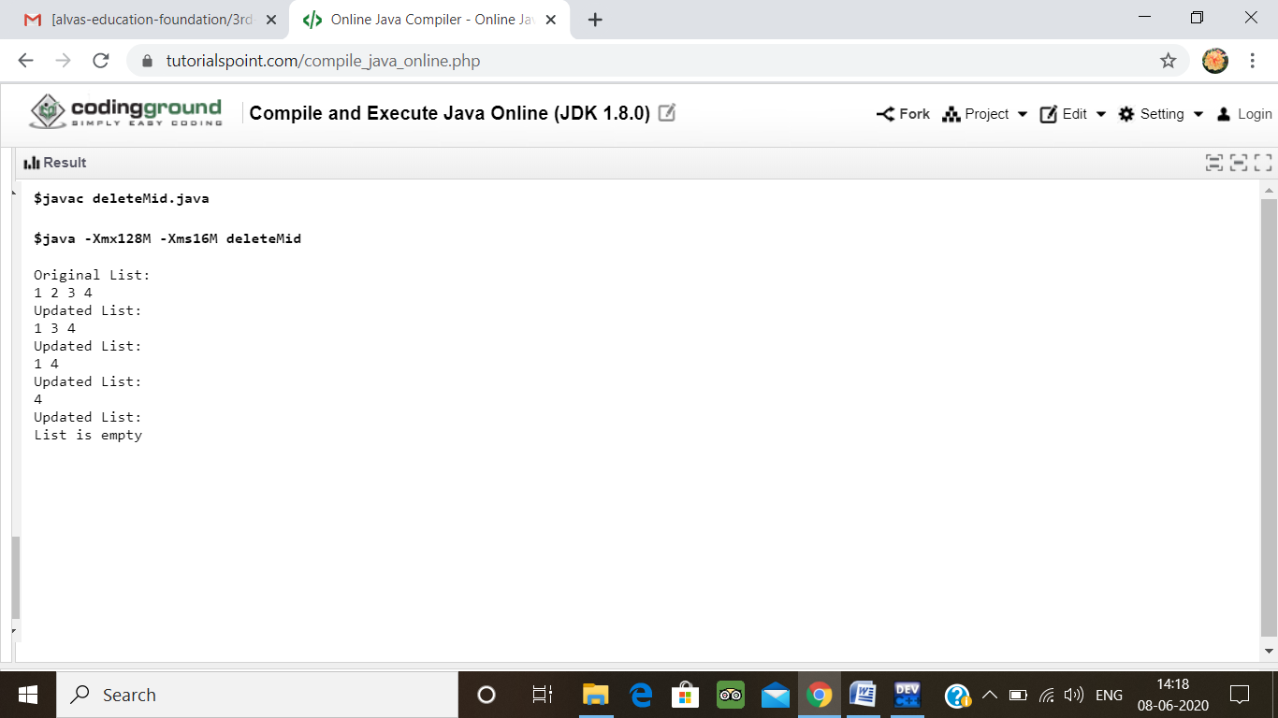

4.

